CHEMICAL ENGINEERING TRANSACTIONS  VOL. 91, 2022 | A publication of
The Italian Association
of Chemical Engineering
Online at www.cetjournal.it

Guest Editors: Valerio Cozzani, Bruno Fabiano, Genserik Reniers
Copyright © 2022, AIDIC Servizi S.r.l.
ISBN 978-88-95608-89-1; ISSN 2283-9216

Quality of Energy Conservation in an Avocado Oil Extraction Process Via Exergy Analysis
Tamy Herrera, Vianny Parejo, Ángel González-Delgado*
Nanomaterials and Computer-Aided Process Engineering Research Group (NIPAC), Chemical Engineering Department, Faculty of Engineering, University of Cartagena, Cartagena 130015, Colombia
agonzalezd1@unicartagena.edu.co
Supply chains in Creole-Antillean avocado production are not highly efficient in Colombia and large quantities of this product are wasted due to fruit deterioration. There, it is important to identify alternatives of waste valorization such as avocado oil production. To assess the viability of large-scale avocado oil production from a sustainability point of view, related to the quality of energy conservation, decision-making tools such as exergy analysis must be applied. In this work, an exergy analysis was carried out to identify sources of irreversibilities within the large-scale production of such oil. The conversion of avocado pulp into oil was simulated through the software Aspen plus ® to obtain the extended mass and energy balances. The chemical and physical exergies were quantified and used to calculate the global exergetic efficiency as well as the efficiency by stages of the process. From this analysis, it was found that the stage with the highest waste exergy corresponds to the centrifugation stage. Likewise, it is possible to observe that the greatest irreversibilities in the process occur in the solvent distillation, condensation, and cooling stage 2,754.49 MJ/h. The peel and seed separation showed an exergetic efficiency of 99.0 %, while the overall exergy of the process obtained was 26.80 %. This work provided insights into the energetic performance of avocado oil production.
  - Introduction
The production of tropical fruits in Latin America and the Caribbean represents approximately 70 % of world production, the avocado being the fifth most important tropical fruit in the world, measured in terms of volume and cultivated area. Colombia is the fourth producing country and the third in terms of area harvested worldwide for avocado. The Antillean, Guatemalan, and Mexican avocado races and hybrids between them, are those that are cultivated in the country (UGRA, 2018). This fruit is grown mainly in the departments of Bolívar, Cesar, Caldas, Valle del Cauca, Antioquia and Tolima, representing 86% of production (Granados Perez and Valencia Rincón, 2018). Due to the climatic conditions of the department of Bolívar, in the Montes de María avocados of the Creole-Antillean variety (Laurus Persea L) are grown. The largest avocado production area is concentrated in El Carmen de Bolívar and San Jacinto. The Montes de María region has an abundant avocado production; in recent years, the deterioration and accumulation of the fruit have been observed, due to the poor state of the access roads for transport, the presence of fungi, and the lack of harvesting strategies, among others. According to this, more and more ways of using this fruit are known. Industrially, the pulp is contacted with an organic solvent through different stages, obtaining an oil that, due to its qualities, can replace olive oil. Its fats are also used in the manufacture of cosmetics, creams, and soaps, this being one of the forms of industrial use of avocado (Amórtegui, 2001; Martinez Nieto et al., 1992).
To obtain avocado oil, different methods can be used. Some of them involve the presence of organic solvents and the application of high temperatures, accompanied by refining processes called bleaching and deodorization. Solvent extraction can be performed with petroleum ether, ethyl ether, benzene, among others. Due to the high moisture content of avocado pulp, extraction techniques with hydraulic pressing (cold pressing) or extraction methods or organic solvents require conditioning of the raw material, requiring a drying process before submitting the pulp to the oil extraction process. Centrifugation is another method to obtain oil, especially when a product is required for food use. The highest oil yields are obtained using organic solvents, with an extraction between 60 and 90 % of the oil. While using production techniques such as centrifugation, yields from 30 to 80 % can be obtained (Yepes Betancur et al., 2017). This study seeks to evaluate the Creole-Antillean avocado oil production process (Laurus Persea L), taking advantage of the pulp of this fruit grown in the Montes de María region, the conversion of the pulp into oil was simulated in the Aspen plus software. An exergy analysis was performed to identify irreversibilities within the process. In addition, chemical and physical exergies were considered, so that they help in the calculation of the global exergetic efficiency, as well as the efficiency by stages of the process. In the same way, this study aims to find currents that can be used, which allow reducing the losses due to existing exergy. With this work, we want to obtain information about the performance of the process from the energy point of view and propose the improvements that it requires to increase its exergetic efficiency.
  - Materials and methods
The operation was simulated in the Aspen Plus software where the physical exergy values of the streams were obtained considering the composition, pressure, and temperature. The UNIQ-RK model (Uniquac and Redlich-Kwong) was used to simulate the thermodynamic properties of compounds, where the Redlich-Kwong equation of state was used as a model of the vapor phase. Table 1 shows the flowrate, pressure and temperature of main streams of the process.
    - Process description
Table 1: Main streams process-operating conditions.
Streams | 1 | 2 | 12 | 16 | 20 | 23 | 25 | 27 | 32
m (t/y) | 10,605 | 11,967.36 | 4,200.00 | 5,784.74 | 6,471.05 | 5,383.62 | 4,649.57 | 1,000.67 | 309.21
T (K) | 298.15 | 298.15 | 298.15 | 298.15 | 343.15 | 326.70 | 326.70 | 298.15 | 298.15
P (bar) | 1 | 1 | 1 | 1 | 0.30 | 1 | 1 | 1 | 1

Figure 1 shows the order of the steps described above for the avocado extraction process. For stage 1, the ratio of washing water and sodium hypochlorite avocado disinfection was reported in the literature (Acosta, 2011). 10,605 t/y of avocado feed the operation, which is processed to obtain 1,000.66 t/y of avocado oil, this is achieved through the extraction that requires 3,848.65 t/y of solvent, hexane for this case. Hexane as solvent is easy to recover has selectivity towards neutral lipids and is inexpensive (González et al., 2009). 309.21 t/y of fresh hexane are fed to the process in stream 32, and 109.47 t/y are purged in stream 29 in order to avoid solvent saturation. The process occurs at one atmosphere of pressure; however, the temperature varies in the different stages. The drying stage was set in 70 °C to conserve the properties of the pulp, oil extraction yield obtained was 65.19 % on a dry basis.

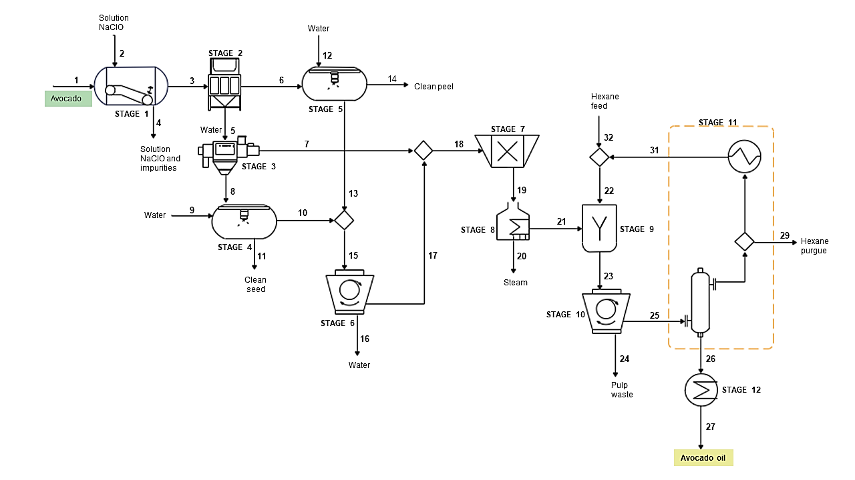
Figure 1: Process flow diagram of Creole-Antillean avocado oil extraction.
For avocado oil production via solvent extraction, there are 8 stages named and described in the table 2. These stages are defined to facilitate the development of the exergetic analysis. According to this, it is possible to observe in one stage two or more conditioning processes of the raw material or unit operations that intervene in the process of extraction avocado oil.
Table 2: Process stages description.
Stage | Name | Description
1 | Avocado washing | Avocado is washed with a sodium hypochlorite solution to remove impurities.
2 | Peel and seed separation | The pulp of the fruit is separated from the skin and seed.
3 | Seed washing | This washing is used to remove the pulp remaining in the seed and then can be used as raw material for other processes.
4 | Peel washing | This washing is used to remove the pulp remaining in peel and then can be used as raw material for another process.
5 | Water separation | Water from the washing stages is separated by centrifugation.
6 | Homogenization and drying | A uniform paste is formed from the pulp, then the pulp is dehydrated to obtain better results in the extraction.
7 | Oil extraction and centrifugation | The dehydrated pulp is mixed with hexane (solvent) to obtain the oil. Following that, the mixture is centrifuged to remove suspended solids as pulp waste.
8 | Distillation, condensation, and cooling | Avocado oil and hexane are separated by a difference in boiling points; part of the solvent is purged, and the rest is recirculated. The temperature reached by oil in the distillation stage is lowered; the storage conditions must be taken care of since high temperatures favours oxidation processes. (Robayo, 2016).
    - Exergy analysis
An exergy analysis makes it possible to quantify the energy quality of a process, in the same way, with this type of analysis modifications can be proposed to make the most of the energy involved in the system or process (Gorozabel-Chata and Carbonell-Morales, 2016). Exergetic analyzes apply the principles of the first and second laws of thermodynamics. The purpose of this type of evaluation is to identify what causes the losses or destruction of the exergy, which allows proposing opportunities for improvement in the processes (Avilés et al., 2020; Li et al., 2019). For the development of the exergetic evaluation, it was necessary to know the properties of the substances that intervene in the avocado oil production process, such as chemical exergies, molecular weights, compositions. Likewise, for currents, it is required to know physical exergies, temperatures, pressures, mass flow, among others. All these values were used in the determination of specific exergies for currents, exergies of residues. The data obtained allow the exergy analysis of the process to be carried out, through which it is possible to determine the irreversibilities in the process and the adjustments that must be made so that the streams and energy losses are used in the avocado oil production process minimal.
Table 2: Equations used in exergy analysis
Name | Equation | Number
Exergy loss | $$Ex_{loss}=E{x_{mass}}_{net}+E{x_{heat}}_{net}+E{x_{work}}_{net}$$ | 1
Exergy by work | $$Ex_{work}=W$$ | 2
Exergy by heat | $$Ex_{heat}=\sum{\left(1-\frac{T_{0}}{T}\right)Q}$$ | 3
Exergy by mass | $$Ex_{mass}=Ex_{ch}+Ex_{phy}$$ | 4
Chemical exergy | $$Ex_{ch}=∆G_{f}^{0}+\sum{v_{j} {Ex}_{ch-j}^{0}}$$ | 5
Chemical exergy of process streams | $$Ex_{ch-mixture}=\sum{y_{i}Ex_{ch-i }+RT_{0}\sum{y_{i}ln y_{i}}}$$ | 6
Exergy total inputs | $$Ex_{total in }=\sum{Ex_{mass in}+\sum{ex_{utilities in }}}$$ | 7
Process irreversibilities | $$Ex_{total loss }=Ex_{total in}-\sum{Ex_{out products}}$$ | 8
Unavoidable exergy losses | $$Loss_{ex}= Ex_{total in}-\sum{Ex_{total out}}$$ | 9
Exergy efficiency | $$η_{ex}=1-\left(\frac{{Ex}_{loss}}{Ex_{total in}}\right)$$ | 10
In table 2, the equations used in the development of the exergetic evaluation are shown. Eq. (1) relates the net exergies by transfer of mass, work, and heat. For its part, Eq. (2) refers to work in a system in which there is no change in volume. The exergy related to heat flow involves the Carnot efficiency considering the reference temperature and is defined by Eq. (3). In most processes, the potential and kinetic exergies are neglected, considering for the exergy by mass only the effects of physical and chemical exergies, as shown in Eq. (4) (Jiaa et al., 2017). Eq. (5) is used to determine the chemical exergy of a substance, while Eq. (6) is used to calculate the chemical exergies of a mixture. In the present study, some of the chemical exergies were calculated using the equations and others were obtained from the literature. In Eq. (7), the total input exergy is observed, which associates the mass flows that enter the system with industrial services (Herrera-Rodríguez et al., 2019).
To identify and quantify irreversibilities, Eq. (8) is used. In the processes some losses cannot be recovered, these can be determined using Eq. (9) and are called unavoidable exergy losses, which fulfill the second principle of thermodynamics. The exergy loss is classified as avoidable and unavoidable, which allows determining the recoverable energy potential of the cycle or process. The inevitable loss of exergy must have a minimum potential difference as the driving force, which is given by differences in temperature, pressure, and chemical potential; therefore, the potential difference leads to a loss of exergy, increasing both proportionally (Cheng et al., 2018). Finally, with Eq. (10) it is possible to calculate the exergy efficiency of the process considering the exergy destroyed and the total inputs (Peralta-Ruiz and González-Delgado, 2018). For the oil production process from avocado pulp, exercise analyzes are not reported to allow comparison with the results obtained in the present study. However, in his research, Özilgen reports that avocado oil has approximate exergy of 39.0 MJ/kg (Özilgen, 2018). The maximum useful work produced from the chemical and physical equilibrium of a substance with the environment is known as the chemical exergy of the substance (Ojeda et al., 2009). The chemical exergies of the compounds involved in the process were consulted in the literature or calculated through equation 5 presented above.
2.2.1Assumptions
To develop a successfully perform exergetic evaluation; the considerations were followed during the calculations:
- The reference conditions are 25 °C and 1 atm.
- The process is operated at steady state
- Kinetic and potential exergies flow are neglected taking into account that their magnitudes are not significant compared to physical and chemical exergies (Moreno-Sader et al., 2019).
  - Results and discussion
The material flow corresponds to 10,605.00 ton/y of avocado. Taking into account the process data and the extended mass and energy balances, the exergy for work and heat, the exergetic efficiency, and the irreversibilities were calculated. In drying and distillation, condensation and cooling, there is an exergy by heat shown in table 3.
Table 3: Exergy for work and heat calculated for the stages.
Stage number | Exergy of work (MJ/h) | Exergy of heat (MJ/h) | Unavoidable exergy losses (MJ/h)
1 | 14.40 | 0.00 | 17.75
2 | 93.60 | 0.00 | 84.06
3 | 14.40 | 0.00 | 16.01
4 | 14.40 | 0.00 | 15.48
5 | 79.20 | 0.00 | 70.41
6 | 378.00 | 219.70 | 54.61
7 | 414.00 | 0.00 | 419.83
8 | 2,181.60 | 38.32 | 2,213.57

The exergy per work was calculated using the power of the equipment selected for the process and applying equation number 2 from table 2; For exergy by heat, the duty obtained by the simulation was used and the calculation was developed with equation 2 from the same source. Unavoidable exergy losses were calculated using equation 9, the greatest losses occur in the distillation, condensation, and cooling stage, where the operating pressure is close to 1 bar, however, a notable change in temperature occurs. In the drying, distillation, condensation, and cooling stage there are inevitable losses attributed to temperature increase and operation pressure variation concerning the reference state. For the others stages it is necessary to consider the difference in chemical potential in unavoidable exergy losses. The generation of entropy in a process causes losses of exergy due to its irreversibility (Mugi and Chandramohan, 2021). For this reason, it is necessary to specify the reference environment with variables such as temperature, pressure, and chemical composition.

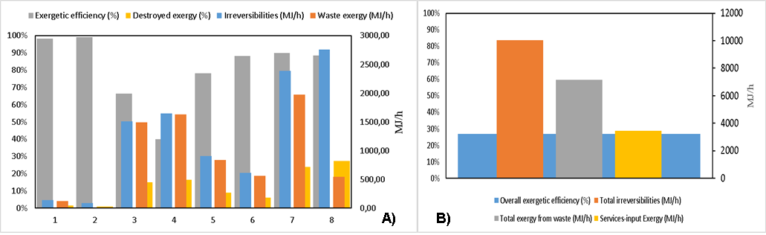
Figure 2: A) Process results for each stage and B) Total process parameters.
The study of process stages is observed in figure 2A, where the highest exergy of residues occurs in the centrifugation stage, due to the amount of pulp residue that comes out of the process, which contains water, solvent, protein, ash, and a low portion of lipids. On the other hand, the greatest irreversibilities occur in the distillation, condensation, and cooling stage, given by a big amount of services input exergy. This stage shows a percentage of exergetic efficiency of 88.5 %, similar to homogenization and drying at 88.3 %. The lowest exergetic efficiency was peel washing (stage 4) 40.0% and seed washing (stage 3) 66.3 %, attributable to the waste amount that came out from these stages. The stages with the highest exergy efficiency were peel and seed separation (stage 2) 99.0 % and avocado washing (stage 1) 98.4 %; these stages presented minor irreversibilities, associated with the destruction of exergy given by the entropy generated caused by the operation of the equipment of the stages. Total process irreversibilities are in order of 10,047.79 MJ/h and the overall process efficiency is 26.80 % as shown in figure 2B, this efficiency is signally lower than reported for crude palm oil production (Martínez et al., 2016) whose overall exergetic efficiency is 59% and drying the most efficient step. These results can be associated mostly with a large amount of waste all over the process, also to factors such as the difference in raw material type, product quantity exploited from the raw material, the extraction process, the equipment used, as well as the energy requirements and industrial services.
The exergy by industrial services has the highest contributions from the distillation, condensation, and cooling stage around 64 % of the total, therefore the process requires a total of 3,447.62 MJ/h. The energetic cost of the process could decrease taking advantage of the heat currents diffused to the environment; For this, it is necessary to carry out an energetic integration as an additional tool that allows optimizing the use of thermal energy and in turn, reducing this expense. The exergy due to residues can be significantly reduced if the seed, peel, and pulp waste are taken advantage of; besides, it could contribute to process overall exergetic efficiency increase.
  - Conclusions
The exergetic analysis of the process of obtaining avocado oil with solvent was performed, in which the critical stages with high irreversibilities, consumption of industrial services, and inevitable losses of exergy were identified. This type of analysis is useful to determine an evaluation of the performance of the process, by determining the location, type, and real size of waste and losses, contributing to the objective of more efficient use of energy, providing the possibility of designing more efficient thermal systems by reducing existing sources of inefficiency. For the transformation of 10,605 t/y of avocado into 1,000.66 t/y of avocado oil, it was obtained that distillation, condensation, and cooling stage identified the largest unavoidable exergy losses, also showing high destroyed exergy. The highest exergy of residues was evidenced in the centrifugation stage also in seed and peel washing. The global efficiency of the process was 26.80%. An energy integration is recommended to take advantage of the exchange network and reduce energy expenditure.
Acknowledgments
Authors thank to University of Cartagena, the Colombian National Planning Department and the Colombian
Ministry of Science, Technology and Innovation (MINCIENCIAS) for the supply of equipment and software
necessary to conclude successfully this work via Project BPIN Code 2020000100325.

References
Acosta M., 2011, Evaluación y Escalamiento del Proceso de Extracción de Aceite de Aguacate Utilizando Tratamiento Enzimático [Universidad Nacional de Colombia], In Universidad Nacional De Colombia, https://repositorio.unal.edu.co/handle/unal/7633
Amórtegui I., 2001, EL cultivo del Aguacate, In PROHACIENDO, http://bibliotecadigital.agronet.gov.co/jspui/bitstream/11348/4911/1/El cultivo del aguacate.pdf
Avilés J., Locarno E., González Á., 2020, Exergetic analysis of TiO2 nanoparticle production from lemongrass and titanium isopropoxide, PROSPECTIVA, 18(2).
Cheng Q., Zheng A., Yang L., Wu H., Lv L., Xie H., Liu Y., 2018, Studies of the unavoidable exergy loss rate and analysis of influence parameters for pipeline transportation process, Case Studies in Thermal Engineering, 12, 517–527.
González A., Kafarov I., Guzmán A., 2009, Development of methods of extraction of oil in the production line of biodiesel from microalgae, PROSPECTIVA, 7(2), 53–60. https://www.redalyc.org/pdf/4962/496250976007.pdf
Gorozabel F., Carbonell T., 2016, Current and future perspectives of direct expansion solar assisted heat pumps, Ingeniería Mecánica, 19(1), 49–58. http://www.ingenieriamecanica.cujae.edu.xn--cu49artculoderevisin-v4b8l
Granados W., Valencia J., 2018, Cadena de Aguacate - Indicadores e instrumentos, In MINAGRICULTURA, https://sioc.minagricultura.gov.co/DocumentosContexto/A1232-Bullets aguacate Septiembre_.pdf
Herrera T., Miranda L., González Á., 2019, Computer-Aided Exergy Sensibility Analysis of Nitrobenzene Production through Benzene Nitration Using an Acid Mixture, International Journal of Chemical Engineering, 2019, 1–7. https://doi.org/10.1155/2019/6986709
Jiaa Z., Chib R., Sunc H., 2017, Biodiesel Processes Energy Improvement based on Pinch and Exergy Analysis, Chemical Engineering Transactions, 61, 487–492. https://doi.org/10.3303/CET1761079
Li W., Zhuang Y., Liu L., Zhang L., Du J., 2019, Economic, exergy, environmental (3E) analysis of methanol production from shale gas, Chemical Engineering Transactions, 76, 655–660. https://doi.org/10.3303/CET1976110
Martínez D., Puerta A., Mestre R., Peralta Y., González Á., 2016, Exergy-based evaluation of crude palm oil production in North-Colombia, Australian Journal of Basic and Applied Sciences, 10(18), 82–88. http://creativecommons.org/licenses/by/4.0/
Martínez L., Barranco R., Moreno M., 1992, Avocado oil extraction: An industrial experiment, Grasas y Aceites, 43(1), 11–15.
Moreno K., Meramo S. I., González A., 2019, Computer-aided environmental and exergy analysis as decision-making tools for selecting bio-oil feedstocks, Renewable and Sustainable Energy Reviews, 112, 42–57.
Mugi V., Chandramohan V., 2021, Energy and exergy analysis of forced and natural convection indirect solar dryers: Estimation of exergy inflow, outflow, losses, exergy efficiencies and sustainability indicators from drying experiments, Journal of Cleaner Production, 282, 124421.
Ojeda K., Quintero V., Rondon S., Karof V., 2009, Análisis exergético del proceso de producción de etanol lignocelulósico como herramienta para evaluar la sostenibilidad de la industria de los biocombustibles de segunda generación, Memorias Del IV Simposio de Química Aplicada – SIQUIA 2009, 1–12. http://blade1.uniquindio.edu.co/uniquindio/eventos/siquia/siquia2009pon4.pdf
Özilgen M., 2018, Nutrition and production related energies and exergies of foods, Renewable and Sustainable Energy Reviews, 96, 275–295. https://doi.org/10.1016/j.rser.2018.07.055
Peralta Y., Obregón L., González A., 2018, Design of Biodiesel and Bioethanol Production Process from Microalgae Biomass Using Exergy Analysis Methodology, Chemical Engineering Transactions, 70, 1045–1050. https://doi.org/10.3303/CET1870175
Robayo A., 2016, Caracterización fisicoquímica de diferentes variedades de aguacate, Persea americana Mill. (Lauraceae) e implementación de un método de extracción del aceite de aguacate como alternativa de industrialización, In Universidad Nacional de Colombia. https://repositorio.unal.edu.co/handle/unal/59451
UGRA U., 2018, Ficha de Inteligencia: AGUACATE. In FINAGRO - Fondo para el financiamiento del sector agropecuario. https://www.finagro.com.co/sites/default/files/node/basic-page/files/ficha_aguacate_version_ii.pdf
Yepes D., Sánchez L., Márquez C., 2017, Thermomechanical extraction and physico-chemical characterization of avocado oil (Persea americana Mill.cv.Hass), Informador Técnico, 81(1), 75. https://doi.org/10.23850/22565035.728

